Findings

A query is written that returns the average price, rounded to two decimal places, for a four-bedroom house that was sold in each year.

A query is written that returns the average price, rounded to two decimal places, of a home that has three bedrooms and three bathrooms.

A query is written that returns the average price of a home with three bedrooms, three bathrooms, two floors, and is greater than or equal to 2,000 square feet for each year built rounded to two decimal places.

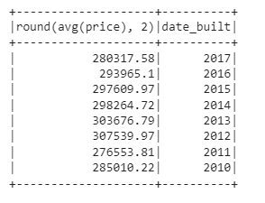

A query is written that returns the view rating for the average price for homes that are greater than or equal to $350,000, rounded to two decimal places. (The output shows the run time for this query.)

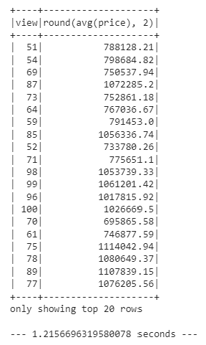

Using the cached data, run the query that filters out the view ratings with an average price of greater than or equal to $350,000. Determine the runtime and compare it to uncached runtime. Partition by the "date_built" field on the formatted parquet home sales data.

A cache of the temporary "home_sales" table is created and validated

A partition of the home sales dataset by the "date_built" field is created, and the formatted parquet data is read.

